Puruni Childcare
Orientation and Training Guide
Introduction to the Classroom

Center:
Director:
Teacher:
Daily Schedule

[~8:30] Arrive at the center to get extra prep time

[8:30-9:00]

Prep work and light play

[9:00-9:30] Snack time

[9:30-11:00] Free play

[11:00-11:15] Transition time

[11:15-11:45] Circle time

[11:30-12:30] Physical play / Library play

[12:30-12:45] Lunch transition time

[12:45- 1:15] Lunch Time

[1:15-1:30] Nap preparation

[1:30-2:00] Daily report and prep time

[2:00 ~] Stay later when needed to finish your work

Orientation Schedule and Guide
Week 1 – Observation Week
During this week the Teacher will sit in the classroom and focus on various points throughout the week. The Teacher should take notes and give the observation document to the director at the end of each day.
Day 1  9:00-1:00PM  Teacher observation 1 | Day 2  8:30-2:00pm  Teacher observation 2 | Day 3  8:30-2:00pm  Teacher observation 2

Week 2 – Interaction with children & Meeting
8:30-2:00pm
During this week the Teacher will play with children, but not plan or prepare activities. The Director or Korean Co-Teachers should assign some activity for the Teacher to do every day. Or just encourage the Teacher to participate with children in free play.
During this week the teacher should take some time to plan and prepare some activities for the next week with children.
Monday – Wednesday  The teacher should research some activities using the intranet and other sources.  The Teacher should prepare samples, ideas and an English goal list. | Thursday  The Director, Korean Teachers and English Teacher should meet and make a plan for the next week. All roles should be assigned clearly. | Friday  The English Teacher should begin to prepare activities for the next week. Also, if adjustments should be made it will be a good time to do it. Also, the Korean Teachers can offer tips.

Week 3 – Normal Week
8:30-2:00pm
The teacher will introduce their preparations and begin to write daily reports. By this time the program should be running normally.
Week 4 –Daily Reports
The Teacher can begin to prepare and write daily reports.

Week 1 Observation Guide Day 1
Teacher:
Date:
Time: 9:00-1:00 (Free Play + Physical Play + Lunch)
Teacher Observation
Observe the English teacher and Korean teachers and write the role each had for the day. Take some time to interact with the children on a 1 to 1 basis.
Free play time

Clean-up time

Group Time (circle time)

Physical play time

Lunch time

What did you notice today that you didn’t see the previous day?

Week 1 Observation Guide Day 2 (Your center)
Teacher:
Date:
Time: 8:30-2:00 (Free Play + Physical Play)
Choose 1 child and observe their play throughout the day.
What did the child play throughout the day?

How did the child play? (watching others, playing with others, playing alone, etc.)

Who did the child play with and how were the interactions with other children?

What was the child’s interaction with their Teachers?

Week 1 Observation Guide Day 2 (Your center)
Teacher:
Date:
Time: 8:30-2:00 (Free Play + Physical Play + Lunch + Afternoon Prep)
My Role
How do you see yourself in the classroom? How would you work and participate in Puruni?
Morning Hour

Snack Time

Free Play

Clean-up time

Group Time

Physical play time

Lunch time

Nap time

5/6 program 2018-2019 (Subject to change)
1. March  Theme: Joyful Childcare Center  1week: Adapting to my new class  2 week: My class friends  3 week: What I want to play  4 week: Play safely  5 week: Play well together | 2. April  Theme: Spring  1week: Change to spring  2 week: Flowers and trees  3 week: spring picnic
3. May  Theme: My family and me  1week: My Joyful Home  2 week: Mom and Dad I love  3 week: My Body  4 week: My mind  5 week: Things I can do | 4. June  Theme: Animals  1 week: Various animals (1)  2 week: Various of animals (2)  3 week: Insects  4 week: Protect Animals
5. July  Theme: Healthy lifestyle  1week: Wash myself clean  2 week: Do exercises  3 week: Food and healthy body | 6. August  Theme: Summer  1 week: Summer weather and sunshine  2 week: Water play  3 week: Mountain and sea  4 week: Let’s take trips

5/6 program 2018-2019 (Subject to change)
7. August thru September  Theme: Transportation  1 week: .Various Transportation 1  2 week: Various Transportation 2  3 week: Transportation play  4 week: Traffic rules and safety | 8. September  Theme: My country and other country  1 week: To represent Korea  2 week: Korean holidays  3 week: Korean and Foreign Food  4 week: Korean and Foreign Houses and Fashion  5 week: Fun folk games
9. October  Theme: Autumn  1 week: Change to autumn  2 week: Grains, fruits and nuts  3 week: leaves and color | 10. November  Theme: My Neighborhood  1 week: Look around my town  2 week: People who help us 1  3 week: People who help us 2  4 week: Shops in my town  5 week: A market pla
11. December  Theme: Winter  1 week: Winter weather and wind  2 week: Winter life and Christmas  3 week: Winter play and safety  4 week: New Year’s Day | 12. January  Theme: Tools and Machines  1 week: Tools seen in the center  2 week: The machines we use  3 week: Convenient tools and machines
13. February

Theme: Me as an Older Brother or Sister

1 week: My class I enjoyed

2 week: Thank you teachers

3 week: Lunar New Year’s Day

4 week: Parting with my class

7 program 2018-2019 (Subject to change)
1. March  Theme: Life and Friends at Childcare Center  1 week: New class and teachers  2 week: New Friends  3 week: The 00 Class promises we made  4 week: Staying together at the center | 2. April  Theme: Spring and animals, plants  1week: Weather Changes and Daily Life  2 week: Spring and plants  3 week: Animals I want to find out about 1  4 week: Animals I want to find out about 2  5 week: Animals we have learned
3. May  Theme: My family and I  1week: Precious family  2 week: Various types of families  3 week: Me in my family  4 week: I am special | 4. June  Theme: My Neighborhood  1 week: The look of my neighborhood  2 week: Institutions in my neighborhood  3 week: Various jobs  4 week: Economy in my life (1)  5 week: Economy in my life (2)
5. July  Theme: Summer and Healthy lifestyle  1week: Summer weather and lifestyle changes  2 week: Getting through the summer in healthy ways  3 week: Body and life  4 week: Have fun in the water | 6. August  Theme: Transportation  1 week: Types of transportation  2 week: Convenient transportation  3 week: Future transportation  4 week: Traffic rules and safety

7 program 2018-2019 (Subject to change)
7. September  Theme: My country Korea  1 week: My country I have traveled  2 week: The Pride of my country  3 week: Life of my country  4 week: The National Holiday | 8. October  Theme: Countries around the world  1 week: Countries I know  2 week: Lifestyles of many countries around the world  3 week: Cultures of many countries around the world  4 week: The world together
9. November  Theme: Autumn and books  1 week: Autumn weather and lifestyle changes  2 week: Autumn forest  3 week: books and information  4 week: Books we make | 10. November Thru December  Theme: Machinery and Life  1 week: Machines in Everyday life  2 week: Energy for activating machines  3 week: Convenient energy
11. December  Theme: Winter  1 week: Changes of winter weather and life  2 week: Wintering of animals and plants  3 week: Winter play  4 week: Winter safety | 12. January  Theme: Earth and environment  1 week: The Earth we live in(1)  2 week: The Earth we live in(2)  3 week: Environmental Protections  4 week: Space exploration
2. February

Theme: Enter elementary school

1 week: The Childcare center I enjoyed/Lunar New Year’s Day

2 week: I am ready to go to school 1

3 week: I am ready to go to school 2

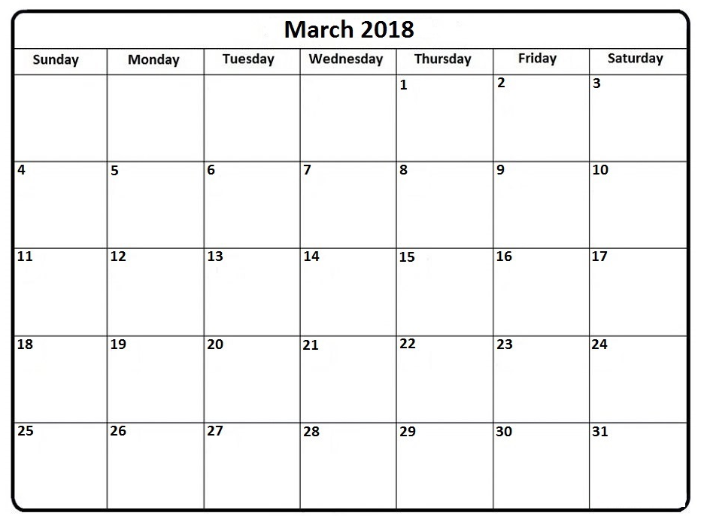
Pay Day
Daily reports
Observation
Free play training
Meeting, co-working & prep
Normal week
AEP Pay Cycle

March Schedule
Training: Class Observation
Varies by teacher
For the first two days, you will observe a more senior member of our staff and learn how to be an IEP teacher. The last two days of your training will be in your own center. Use the attached forms in the beginning of this packet and return completed forms to your director.
Training: Introduction to Free Play
March 5th – 9th
With assistance from your Korean co-Teachers you will begin to play with the children. Also, you will need to begin planning for the following week.
Training: Meetings & Planning
Match 12th – 16th
You will have your first official meeting with Korean co-Teachers. Bring in some ideas and make a schedule together.
Training: First Normal Week
March 19th – 23th
This will be your first normal week of play with the children.
Daily Reports & Lesson Plans
March 26th
You will begin to prepare daily reports and lesson plans. (eng.puruni.com)

Puruni Administration Checklist
Daily Reports
Starting Date: March 26th
Location: Puruni Intranet
Extra: Print and submit to Director Daily (You should ask for a paper folder with a metal clip or binder to use for the full year – make sure to label the folder/binder appropriately)
Weekly lesson Plans
Starting Date: March 26th
Location: Template on Puruni Intranet
Extra: Print and give to Director weekly & Email to johnt@puruni.com monthly
Student Interaction Reports
2x a year
Will review at a later date
For more clarification, see Puruni Manual on center computer

Puruni Vacation Outline
Here is a brief explanation about vacation. The following example assumes a Teacher has started in March, for those who started later you can minus 1 day for every month after March.
Total Vacation Breakdown

- In the first semester you have 6 available vacation days.
  - The fixed days are paid days
  - The first 2 flexible days are paid
  - The 3rd flexible is non paid
  - The 3 fixed days are NON-NEGOTIABLE
- Whatever vacation you DO NOT use in the 1st semester will roll over into the second semester.
- You cannot use more than 6 days of your vacation in the 1st semester without special agreement from your director and manager.
- You CAN use vacation that rolls over into the second semester freely. However, vacation will NOT roll over into the next contract.

Personal Vacation Manager
Please use this template to keep track of your vacation use.
My Total Vacation:
1st Semester | 2nd Semester
3 Fixed | 3 Fixed
Dates: | Dates:
My Flexible Total: | My Flexible Total:
Date:  Paid/Non | Date:  Paid/Non
Date:  Paid/Non | Date:  Paid/Non
Date:  Paid/Non | Date:  Paid/Non
Date:  Paid/Non | Date:  Paid/Non
Date:  Paid/Non | Date:  Paid/Non
Date:  Paid/Non | Date:  Paid/Non

